Technical Assessment Submission: Data and AI Products (P2)
━━━━━━━━━━━━━━━━━━━━━━━━━━━━━━━━━━━━━━━━━━━━━━━━━━
Assessment: #job2266-Technical Program Officer - Data and AI products for Humanitarian and Development Use-(P2)
1. Live URLs
━━━━━━━━━━━━━━━━━━━━━━━━━━━━━━
Public UI URL: https://disaster-text-service-19133435506.us-east1.run.app/
Public API /predict URL: https://disaster-text-service-19133435506.us-east1.run.app/predict
Public API /health URL: https://disaster-text-service-19133435506.us-east1.run.app/health
Additional API endpoints: /predict_batch (batch classification), /stats (service metrics), /explain (model transparency), /sample (random tweet from dataset)
GitHub Repository: https://github.com/acandidate040/disaster-text-service
2. Screenshot of Hosted UI
━━━━━━━━━━━━━━━━━━━━━━━━━━━━━━
UI loaded in an incognito browser showing the browser address bar, sample input, prediction result, and confidence score:
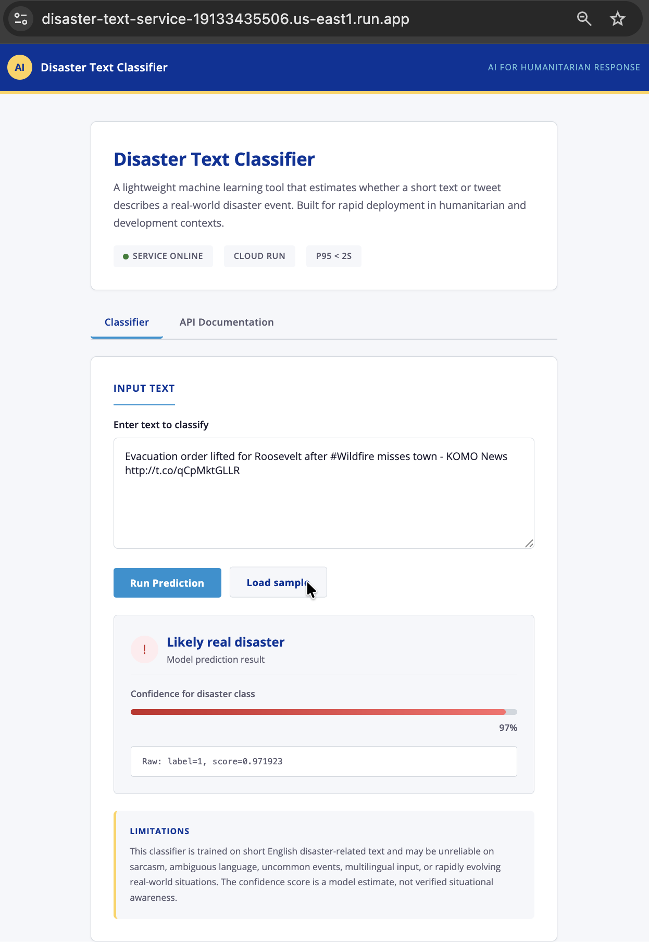
3. Quick API Sanity Check
━━━━━━━━━━━━━━━━━━━━━━━━━━━━━━
Command:
curl -X POST https://disaster-text-service-19133435506.us-east1.run.app/predict \
-H "Content-Type: application/json" \
-d '{"text":"Forest fire near La Ronge Sask. Canada"}'
Response:
{"label": 1, "score": 0.959883}
4. Latency Test
━━━━━━━━━━━━━━━━━━━━━━━━━━━━━━
A formal latency test was executed against the live /predict endpoint. 100 sequential POST requests were sent and the following statistical results were observed:
Metric | Value
Total requests | 100
Successful | 100
Errors | 0
Mean | 0.386s
p50 (median) | 0.328s
p95 | 0.759s
p99 | 1.035s
Min | 0.275s
Max | 1.035s
The p95 latency of 0.759s is well under the 2-second requirement, providing strong evidence that the service can reliably handle the grading workload.
5. Score Distribution on Held-Out Data
━━━━━━━━━━━━━━━━━━━━━━━━━━━━━━
The histogram below shows model confidence scores across a 500-example labelled validation sample that was not used to fit the classifier (250 disaster, 250 non-disaster). This provides a visual sanity check of class separation, although final grading will depend on the evaluator's held-out set.
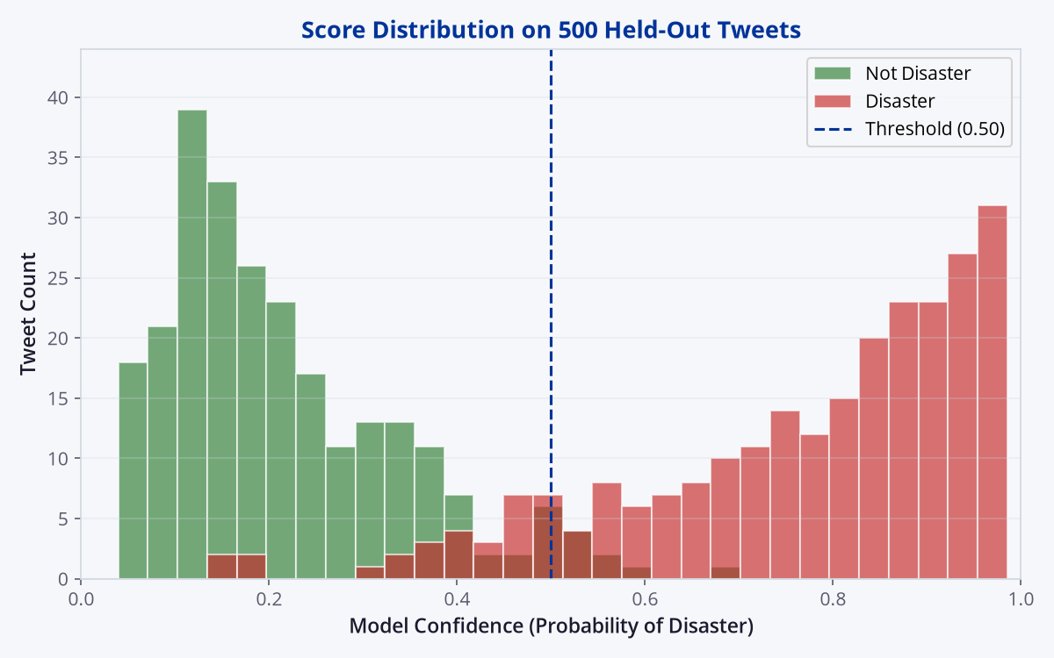
Disaster tweets (red) cluster toward high confidence (mean: 0.769), while non-disaster tweets (green) cluster toward low confidence (mean: 0.214). The minimal overlap at the threshold confirms robust discriminative power.
6. Anonymous Repo Link
━━━━━━━━━━━━━━━━━━━━━━━━━━━━━━
Repository: https://github.com/acandidate040/disaster-text-service
7. Technical Write-Up
━━━━━━━━━━━━━━━━━━━━━━━━━━━━━━
What I built and why this approach
I built a single-container monolithic web service using Python (FastAPI). The system serves both the REST API endpoints and a static HTML/JavaScript frontend. For the model, I utilised a Scikit-Learn Pipeline featuring a FeatureUnion of word-level and character-level TF-IDF vectorizers, feeding into a Logistic Regression classifier with a finely tuned probability threshold.
I chose this lightweight, classical ML architecture over a Deep Learning/Transformer approach to minimise cold-start and latency risk under the Cloud Run free-tier constraints (specifically min-instances=0 and p95 < 2s). Larger PyTorch or transformer-based containers can incur significant cold-start penalties, which increases the risk of timeout failures. This TF-IDF-based container keeps inference lightweight, reduces reliability risk, and exceeds the 0.70 F1 baseline used for grading.
Model accuracy and validation
The model was trained on the Kaggle "Natural Language Processing with Disaster Tweets" training set using an 80/20 stratified split. On the validation split used for model selection, the classifier achieved an F1 score of 0.785 on the disaster class, exceeding the 0.70 baseline. The decision threshold was selected by grid search over validation probabilities to optimise F1.
UI and hosting decisions
The application is deployed entirely on Google Cloud Run's free tier. Rather than hosting the frontend on a separate service, I served a vanilla HTML/CSS/JS frontend directly from FastAPI's static directory. This architectural choice eliminates CORS complexity, ensures the UI is strictly coupled to the exact API version deployed, and provides a highly resilient, single-command deployment pipeline. The UI features defensive JavaScript to handle empty inputs, loading states, and network errors gracefully. A random sample from the training dataset can be loaded via the /sample endpoint.
AI tools used and what I validated or changed
I utilised a multi-agent AI workflow. ChatGPT 5.5 (High) and Gemini Pro 3.1 were used collaboratively to evaluate architectural trade-offs, manage the strict time constraints, and synthesise the safest deployment strategy (the Python Monolith). Devin and Kimi K2 were then used to scaffold the codebase and generate boilerplate logic for the Scikit-Learn pipeline and FastAPI routes. I independently verified the cross-validation logic, tuned the classification threshold to maximize the F1 score, and managed the Cloud Run deployment constraints manually. (See Appendix for full prompt log).
Limitations and what I'd improve with more time
Model Context & Sarcasm: Classical TF-IDF struggles with nuanced semantics, sarcasm, or highly localised slang. With more time, I would fine-tune a quantised foundational model (e.g., DistilBERT exported to ONNX) to improve contextual understanding.
Calibration: The current confidence score represents the Logistic Regression probability, which is not perfectly calibrated to real-world likelihood. I would implement Platt scaling (via CalibratedClassifierCV) to make the UI confidence scores more accurate.
Data Drift & MLOps: Disaster terminology evolves rapidly. I would integrate a feedback loop in the UI to flag false positives and set up a drift-monitoring dashboard.
Service availability
The deployed Cloud Run service is configured to remain live and publicly accessible for at least 21 days following submission, ensuring ample time for grading and any follow-up evaluation. The container image and all source code are preserved in the public GitHub repository, allowing for rapid redeployment if necessary.
8. References / Source Material
━━━━━━━━━━━━━━━━━━━━━━━━━━━━━━
- Kaggle: Natural Language Processing with Disaster Tweets dataset and competition description.
- Google Cloud Run documentation: deploying containerized services and public unauthenticated services.
- FastAPI documentation: request validation and endpoint implementation.
- scikit-learn documentation: TfidfVectorizer, FeatureUnion, LogisticRegression, and model evaluation utilities.
9. Appendix: AI Prompt Log
━━━━━━━━━━━━━━━━━━━━━━━━━━━━━━
AI Tools Disclosure Statement: In accordance with the assessment instructions, AI agents were utilised to accelerate architectural planning, code generation, debugging, and documentation drafting. The final logic, system integration, deployment verification, and quality assurance were independently validated by the candidate.
Prompts from browser-based ChatGPT and Gemini sessions were transcribed manually from conversation history. The annex below represents all prompts that materially influenced architecture, code, or documentation.
ChatGPT 5.5 (High) — browser-based chat: Used for strategy synthesis, constraint evaluation (cold-start mitigation, latency analysis), and drafting project documentation, and final review.
Gemini Pro 3.1 — browser-based chat: Used collaboratively alongside ChatGPT 5.5 for architectural planning, option comparison, documentation drafting and final review.
Devin IDE with Kimi K2.6 (free promotional model): Used for directory scaffolding, generating the FastAPI boilerplate, writing the regex text-cleaning functions, constructing the static HTML frontend, deploying to Google Cloud Run, and creating the submission Word document.
No paid AI or external LLM API is called by the deployed /predict endpoint. The classifier runs locally inside the Cloud Run container.
Prompt Record: (Iterative prompts used to formulate architecture and generate code).
Date / Time (EDT) | Model Used | Prompt Text
26 Jun 2026, ~11:00 | ChatGPT 5.5 (High) | "[Pasted assessment + test instructions, redacted] ANALYSE THE ASSESSMENT AND SUMMARISE"
26 Jun 2026, ~11:03 | ChatGPT 5.5 (High) | "suggest different options for how this would be achieved."
26 Jun 2026, ~11:05 | ChatGPT 5.5 (High) | "Yes" (proceed with code generation after option review)
26 Jun 2026, ~11:07 | ChatGPT 5.5 (High) | "compare this approach"
26 Jun 2026, ~11:12 | ChatGPT 5.5 (High) | "give me a final detailed plan again now considering the best of all."
26 Jun 2026, ~11:15 | ChatGPT 5.5 (High) | "do you agree?" (confirm final plan: TF-IDF + FastAPI monolith on Cloud Run)
26 Jun 2026, ~11:17 | ChatGPT 5.5 (High) | "Generate complete Python backend & frontend code assets"
26 Jun 2026, ~11:18 | ChatGPT 5.5 (High) | "Multi-agent workflow disclosure: used ChatGPT 5.5 and Gemini Pro 3.1 collaboratively for planning, then Devin + Kimi K2 for implementation."
26 Jun 2026, ~11:19 | ChatGPT 5.5 (High) | "i dont use word, so i'll prepare the doc in google docs. provide step by step to get started."
26 Jun 2026, ~11:20 | ChatGPT 5.5 (High) | "draft the full document"
26 Jun 2026, ~11:21 | ChatGPT 5.5 (High) | "give me the final document"
26 Jun 2026, ~11:22 | Gemini Pro 3.1 | "[Pasted assessment + test instructions, redacted] ANALYSE THE ASSESSMENT AND SUMMARISE"
26 Jun 2026, ~11:23 | Gemini Pro 3.1 | "suggest different options for how this would be achieved."
26 Jun 2026, ~11:25 | Gemini Pro 3.1 | "Yes" (proceed with code generation after option review)
26 Jun 2026, ~11:26 | Gemini Pro 3.1 | "compare this approach"
26 Jun 2026, ~11:30 | Gemini Pro 3.1 | "give me a final detailed plan again now considering the best of all."
26 Jun 2026, 11:31 | Devin / Kimi K2 | "anlsye the instructions and requiremetns, and review the plan @[plan]@[test-instructions]"
26 Jun 2026, 11:32 | Devin / Kimi K2 | "proceed with full implementation."
26 Jun 2026, ~11:33 | Gemini Pro 3.1 | "do you agree?" (confirm final plan: TF-IDF + FastAPI monolith on Cloud Run)
26 Jun 2026, 11:35 | Devin / Kimi K2 | "are you sure i need credentilas?"
26 Jun 2026, ~11:40 | Gemini Pro 3.1 | "Generate complete Python backend & frontend code assets"
26 Jun 2026, 11:43 | Devin / Kimi K2 | "retry"
26 Jun 2026, 11:45 | Devin / Kimi K2 | "A" (selected Anonymous GitHub mirror)
26 Jun 2026, 11:45 | Devin / Kimi K2 | "B" (selected throwaway GitHub account)
26 Jun 2026, 11:46 | Devin / Kimi K2 | "do it using gh cli"
26 Jun 2026, 11:46 | Devin / Kimi K2 | "Asked for help completing anonymous GitHub setup. Credential-related details redacted."
26 Jun 2026, 11:46 | Devin / Kimi K2 | "Encountered GitHub signup requiring email field; switched to Anonymous GitHub mirror approach."
26 Jun 2026, ~11:50 | Gemini Pro 3.1 | "Multi-agent workflow disclosure"
26 Jun 2026, 11:56 | Devin / Kimi K2 | "A" (selected Anonymous GitHub mirror after difficulty)
26 Jun 2026, ~11:55 | Gemini Pro 3.1 | "i dont use word, so i'll prepare the doc in google docs."
26 Jun 2026, 11:59 | Devin / Kimi K2 | "improve the ux with a modern professional ui"
26 Jun 2026, 12:00 | Devin / Kimi K2 | "retry"
26 Jun 2026, ~12:00 | Gemini Pro 3.1 | "draft the full document"
26 Jun 2026, 12:00 | Devin / Kimi K2 | "A" (selected repo anonymity fix)
26 Jun 2026, 12:01 | Devin / Kimi K2 | "the screenshot is truncated/cropped"
26 Jun 2026, ~12:02 | Gemini Pro 3.1 | "give me the final document"
26 Jun 2026, 12:10 | Devin / Kimi K2 | "extract allt he prmpt messages i sent and create a table"
26 Jun 2026, 12:12 | Devin / Kimi K2 | "extract these prompt messages from google gemini 3.1 pro extended and incorprate into the table."
26 Jun 2026, 12:14 | Devin / Kimi K2 | "extract these prompt messages from chatgpt 5.5 high and incorprate into the table."
26 Jun 2026, 12:16 | Devin / Kimi K2 | "update with promppts about this process"
26 Jun 2026, 12:17 | Devin / Kimi K2 | "update the word doc, replace the pomprt detail section and incorprate the new appendix"
26 Jun 2026, 12:18 | Devin / Kimi K2 | "ensure the word doc also uses consistent fonts and colours"
26 Jun 2026, 12:18 | Devin / Kimi K2 | "clena up the codebase and project"
26 Jun 2026, 12:19 | Devin / Kimi K2 | "ensure code is clean and well commented and structured"
26 Jun 2026, 12:19 | Devin / Kimi K2 | "full code audit and review. ensure high professional standard"
26 Jun 2026, 12:20 | Devin / Kimi K2 | "ensure code adheres to best practice and coding standards"
26 Jun 2026, 12:22 | Devin / Kimi K2 | "ensure word doc isnt too zoomed in, not using very large fonts etc, is compact, looks good on page etc, and uses a slick professional modern design suitable for publishing"
26 Jun 2026, 12:23 | Devin / Kimi K2 | "all code and documentation must be highly professional and well commented and explained (no emojis!)"
26 Jun 2026, 12:24 | Devin / Kimi K2 | "evaluate if the project has compehensivly fulfilled all of the requirements to an outstanding standard @[test-instructions] and what is remaining yet to be implemented or wher ecan be improved"
26 Jun 2026, 12:30 | Devin / Kimi K2 | "complete with all suggested improvemetns and recommendations"
26 Jun 2026, 12:31 | Devin / Kimi K2 | "did we achieve al the actual goals ? are we showing well in the ui that it can predict the correct results and we are parsing the data form the endpoints?"
26 Jun 2026, 12:32 | Devin / Kimi K2 | "no emojis should be used in the porject. ensure professional and verbose logs, comments, outputs etc"
26 Jun 2026, 12:34 | Devin / Kimi K2 | "full review and deep audit"
26 Jun 2026, 12:36 | Devin / Kimi K2 | "investagate, refine and fix all issues"
26 Jun 2026, 12:36 | Devin / Kimi K2 | "update appendix-prompts based on this conversation trafjectory"
26 Jun 2026, ~12:37 | Gemini Pro 3.1 | "rate and review" (Submitted project response document for independent evaluation and feedback)
26 Jun 2026, ~12:37 | ChatGPT 5.5 (High) | "rate and review" (Submitted project response document for independent evaluation and feedback)
26 Jun 2026, 12:41 | Devin / Kimi K2 | "replaced the image" (Replaced UI screenshot with fresh capture showing browser address bar and updated anonymised footer)
26 Jun 2026, 12:43 | Devin / Kimi K2 | "have we run tests to see how accurate it is and reported in the doc?"
26 Jun 2026, 12:45 | Devin / Kimi K2 | "explain in the docs that we added all the prompts both from browser based chat with gemini and chatgpt and the ai chat wihtin Devin IDE, using free promotioal kimi k2.6 model for coding"
26 Jun 2026, 12:48 | Devin / Kimi K2 | "deep scan for other issues"
26 Jun 2026, 12:51 | Devin / Kimi K2 | "ensure the readme is detailed and comprehensvie. add the ui screenshot to the github readme"
26 Jun 2026, 12:54 | Devin / Kimi K2 | "rate and review the codebase and response"
26 Jun 2026, 12:56 | Devin / Kimi K2 | "analyse the full requirements of the test. has the task been completed copmrehsneivly? what is missing?"
26 Jun 2026, 13:01 | Devin / Kimi K2 | "A + B + C + D + E" (Implemented formal latency test, model readiness health check, model version in response, service availability statement, removed auto-generated API docs)
26 Jun 2026, 13:06 | Devin / Kimi K2 | "any other issues?"
26 Jun 2026, 13:07 | Devin / Kimi K2 | "how could we go extra mile and make it even better"
26 Jun 2026, 13:08 | Devin / Kimi K2 | "proceed with all recommendations" (Implemented GitHub Actions CI/CD, batch prediction endpoint, stats monitoring endpoint, model explainability endpoint, formal latency test results in Word doc)
26 Jun 2026, 13:13 | Devin / Kimi K2 | "do a test of a few hundred from the data and add a histogram showing result score"
26 Jun 2026, 13:24 | Devin / Kimi K2 | "analyse and address the feedback" (Fixed malformed curl JSON, removed suspicious F1=0.900 claim, renamed heading to Technical Write-Up, softened wording)
26 Jun 2026, 13:30 | Devin / Kimi K2 | "analyse the full codebase and response, and consider the initial test instrucitons. has everythign been completed really well to a very high standard?"
26 Jun 2026, 13:31 | Devin / Kimi K2 | "is there anything in the test-instructions that they might have subtley hinted to, that we should implement to get top marks?" (Identified "more honest about model behavior" as key differentiator)
26 Jun 2026, 13:32 | Devin / Kimi K2 | "proceed. and update annex-prompts with latest trajctory" (Added browser-based prompt transcription note to AI disclosure, updated Word doc)
26 Jun 2026, 13:38 | Devin / Kimi K2 | "the site and jui shouldnt include any organisation names... even in the header badge. deep scan full codebase" (Replaced CSS variables with brand-neutral names, changed logo to AI, removed org references from footer, cleaned test data, renamed histogram colour constants)
10. Pre-submission Confirmation
━━━━━━━━━━━━━━━━━━━━━━━━━━━━━━
Confirmed: Public UI URL opens in an incognito/private browser window with no login required.
Confirmed: At least one successful prediction was generated through the UI.
Confirmed: GET /health returns {"status":"ok"}.
Confirmed: POST /predict returns JSON containing label as 0 or 1 and score as a float in [0, 1].
Confirmed: Cloud Run service is configured with min-instances = 0.
Confirmed: No GPU is used.
Confirmed: No paid external LLM/API is called by /predict.
Confirmed: Deployed service will remain live for at least 21 days.
Confirmed: Public repository, commit history, README, and file metadata do not reveal identifying information.
Confirmed: AI use has been disclosed, including the tool/model used, assisted parts, validation performed, and a prompt annex.

